**Sharing a report**

**Introduction**

In the exercise, *Sharing a Report*, you were tasked with a crucial assignment: paginate, publish, and export a Microsoft Power BI report for the financial team at Adventure Works.

More specifically, you were asked to:

* Create new pages for pagination, organizing your data into a more readable format that users can easily navigate.
* Publish your report to the Power BI service, making it available for the financial team and other stakeholders in Adventure Works.
* Export your report as a PDF, providing a portable and easily shareable format for the financial team to review.

This reading provides you with a guide that you can use to compare your solution.

**Instructions**

**Step 1: Open Power BI and the report**

1. Launch Power BI Desktop, select the **File** menu, and navigate to where you've stored your Power BI report file.
2. Select the file, and then select **Open** to load the report.

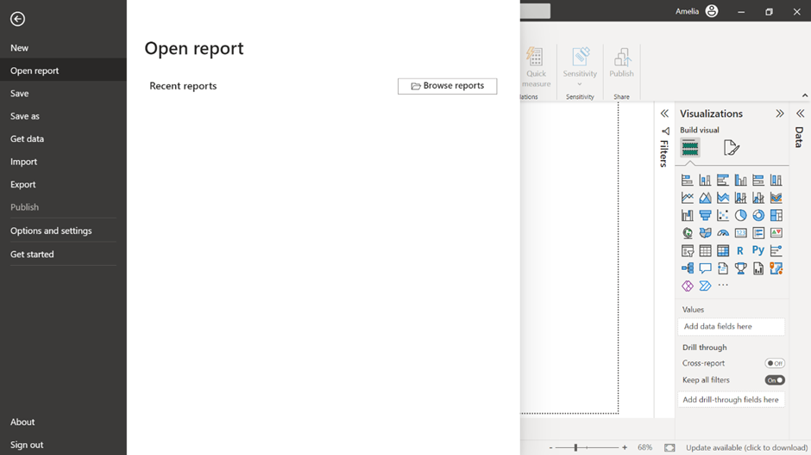

**Step 2: Observe the data**

1. Select the **Data** view on the left side of your screen.

**Note:** This view allows you to view the records you will handle throughout the rest of this exercise.

2. A table representing your data will display towards the middle of your screen. Locate the **Product Name** column and observe the first ten records.

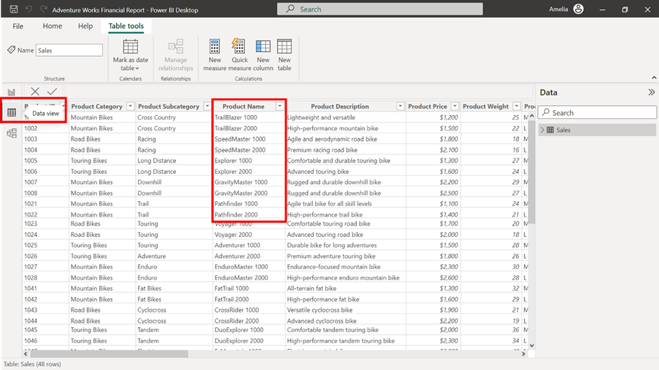

**Step 3: Switch to the Report view**

* On the left side of your screen, select the **Report** view. It's the canvas where you'll paginate your data story, transforming it into a meaningful narrative.

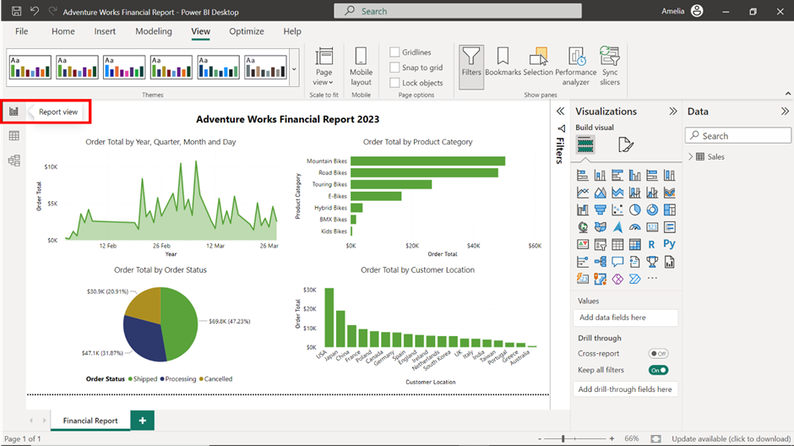

**Step 4: Create pages for pagination**

1. Navigate to the **Pages** section at the bottom left of the screen.
2. Add two new pages by selecting the new page button, represented by a **Plus** sign.

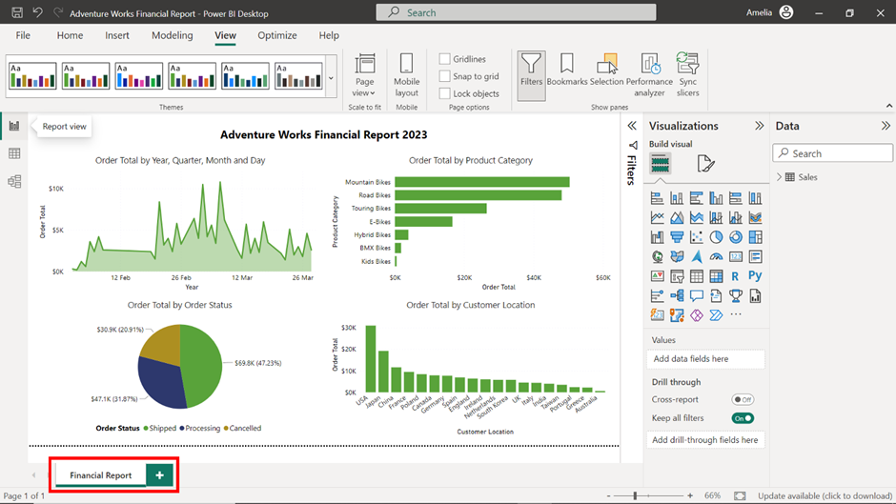

**Note:** This is like creating chapters in a book. Each page or chapter will focus on a specific aspect of the data story. This way, you can guide the financial team through the narrative systematically and logically. It makes the data more digestible and allows for focused analysis.

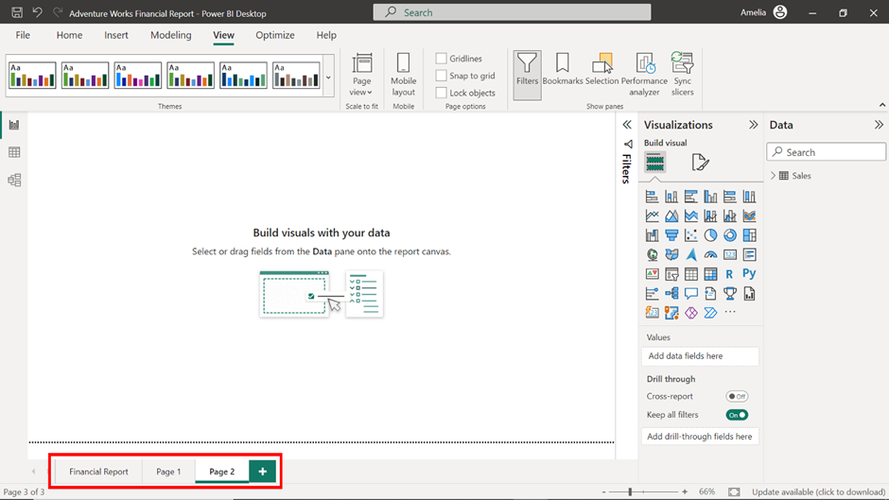

**Step 5: Rename the pages**

**Note:** At the bottom of the Power BI Desktop application window, you'll see tabs representing each page in your report.

1. Select the **tab** for the new page you want to rename to make it active.

**Note:** Just like the chapters of a book, each name should indicate what to expect from that page.

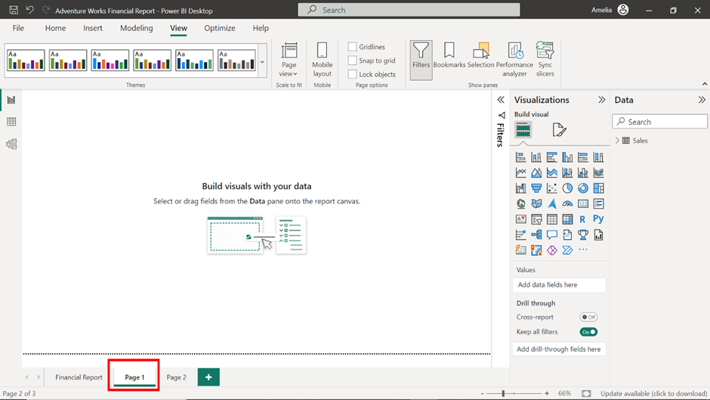

2. Select the **Format** icon on the **Visualizations** pane to open the formatting options for your page.

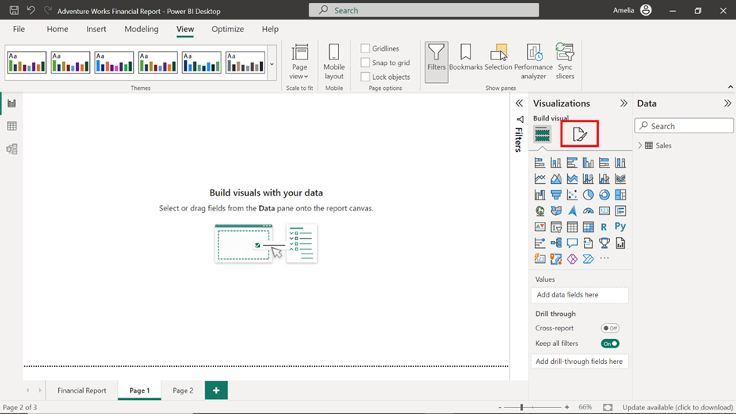

3. Find and select the **Page Information** option to expand the menu.

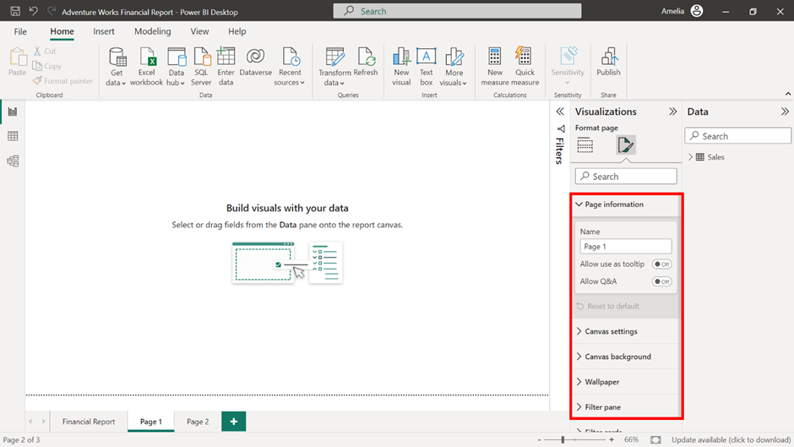

4. From the **Page Information** menu, select the **Name** field. Clear the current name and type in the new name for the page *Sales Monthly Summary*. Click outside the field or press enter to confirm it.

5. Repeat steps 1-4 for the second new page and change the name to *Top Product Categories*. This way, your report is organized into well-defined sections, each clearly labeled, guiding the financial team's data discovery journey.

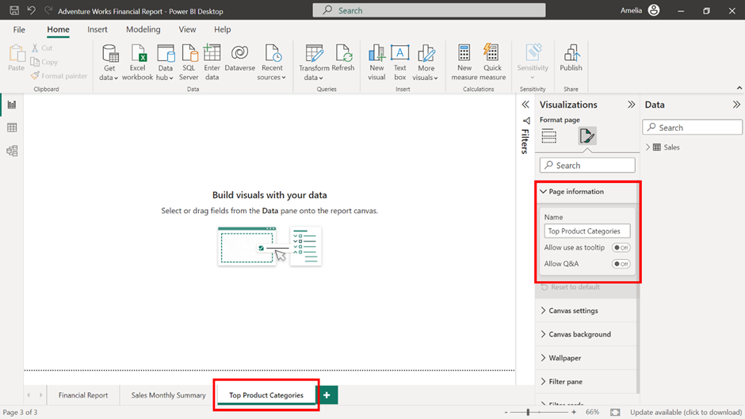

**Step 6: Distribute report content across pages**

It's time to populate your pages.

1. Move the **Order Total by Product Category** visual from your main report to the newly created **Top Product Categories** page.

**Note:** This visual provides insights into product performance, guiding decisions about resource allocation and marketing efforts.

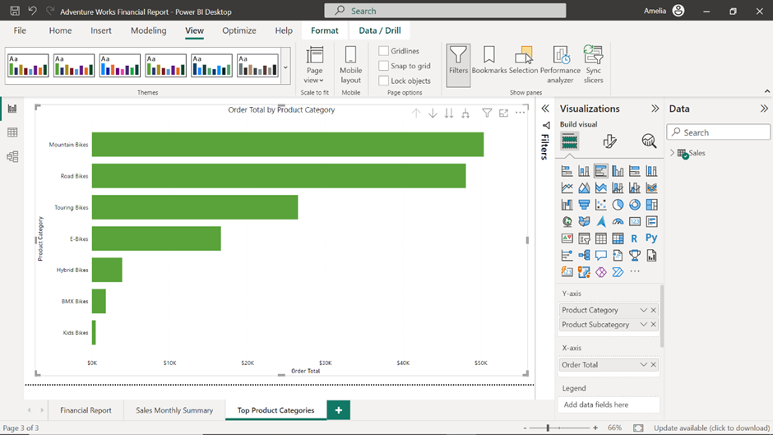

2. Move the **Order Total by Month** visual from your main report to the newly created **Sales Monthly Summary** page.

**Note:** This visual tells a story about timing. It can reveal seasonal trends, inform about peak sales periods, and guide decisions about when to launch new products or promotions.

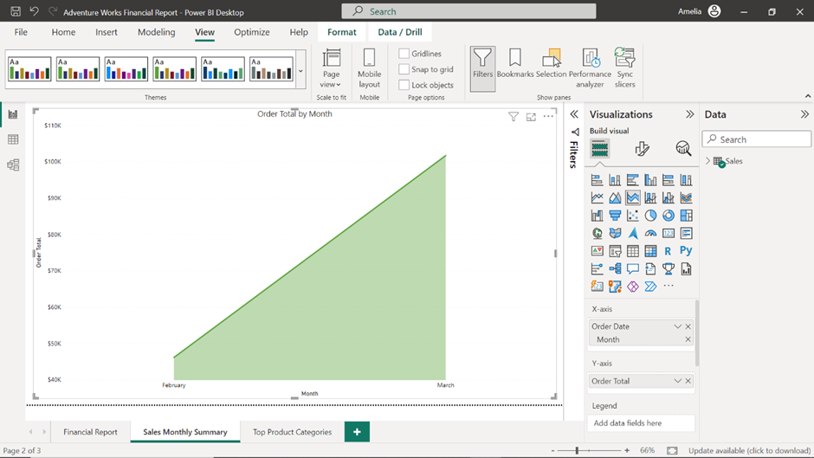

**Step 7: Publish the report**

The first thing to remember before publishing your report to Power BI service is to save it. Think of this step as finalizing the draft of a book before you send it to the publisher.

**Note:** Power BI will not allow the publishing of unsaved reports. It's a built-in safeguard to ensure no work gets lost in the process.

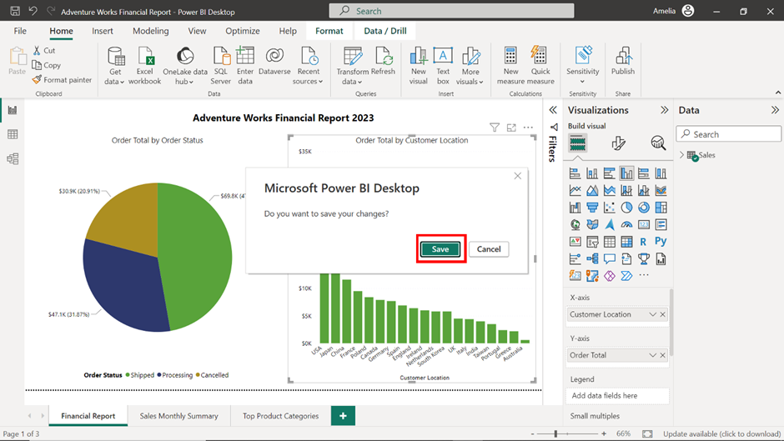

1. Select the **Publish** button in the **Home** tab.

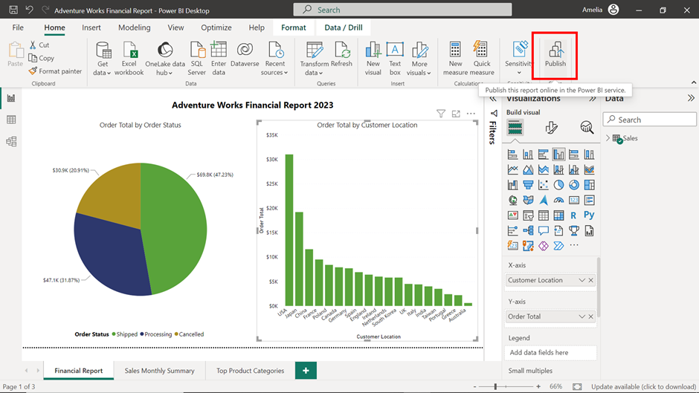

2. Select **My Workspace** from the dialog box and select the **Select** button

**Note:** Consider this step as picking a bookstore to sell your newly published book. After the destination is selected, Power BI begins publishing the report. Depending on the size of the report and your internet connection, this could take a few moments.

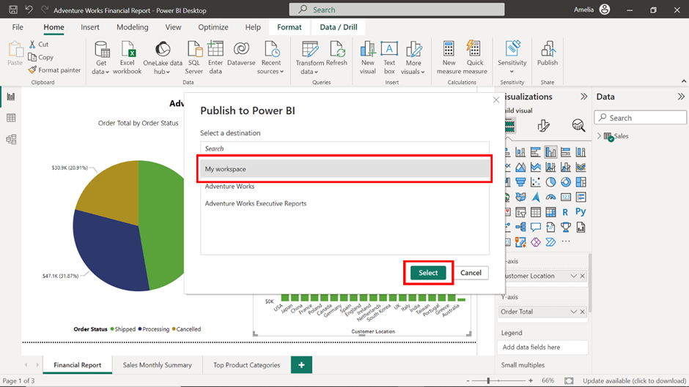

3. After your report is published, a new dialog box will confirm its successful publication. Select **Open** to view the published report in Power BI Service.

**Note:** This is your chance to review your work and ensure everything is in order, much like an author reading their published book.

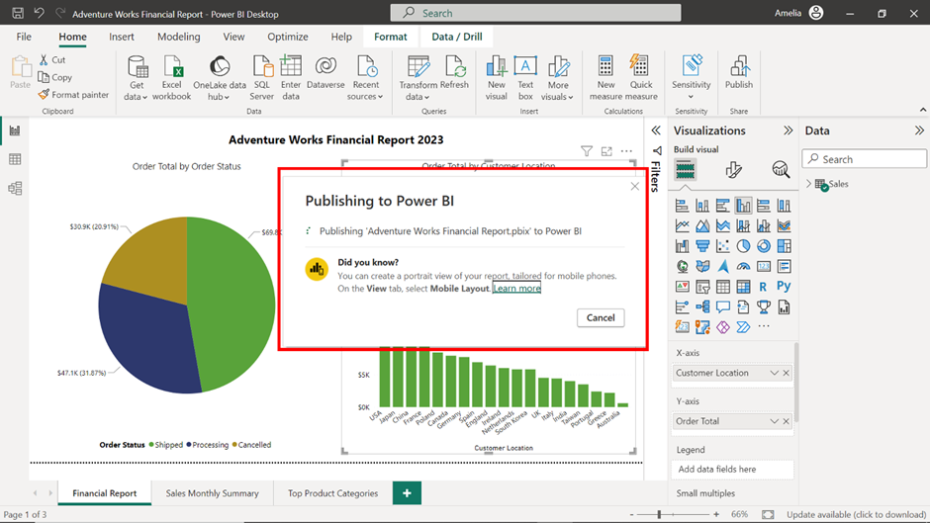

**Step 8: Export the report**

1. With your report open in Power BI Service, select the **Export** button at the top left corner of the screen.

**Note:** This option allows you to create a shareable version of your report, like printing copies of your book for distribution.

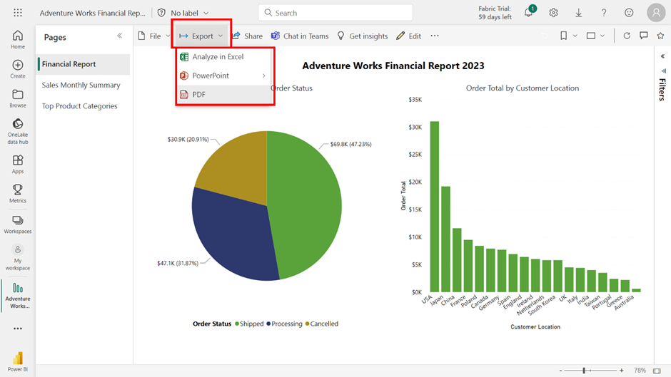

2. When you select the **Export** button, a dropdown menu appears with three options: **PDF**, **PowerPoint**, and **Analyze in Excel**. Select **PDF**.

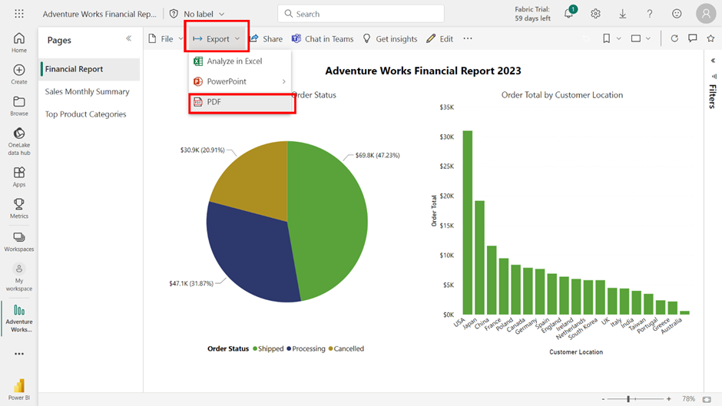

3. After selecting **PDF**, an **Export** pop-up dialog appears. In the **Export with** dropdown, select **Current Values.**

**Note:** This option ensures that the data in the report matches what's currently in your system, providing the most up-to-date insights to the financial team.

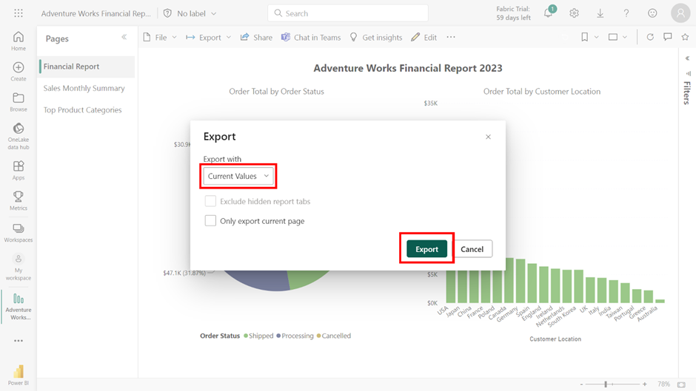

4. Finally, select **Export** to start the export process.

**Note:** The duration will depend on the size of your report. This last step is like the final printing press run, creating a product ready to be handed off to the financial team, providing them with the crucial insights they need to analyze Adventure Works' performance.

